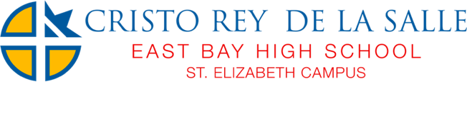

Dear CRDLS community member,

Cristo Rey De La Salle believes in nurturing students in mind, body, and spirit. We are hosting a School Wellness Committee to bring together families, staff, community members and students to help us live this vision. As a CRDLS community member your input is particularly important, and we would be honored to have you as a Wellness Committee member. We hope you will accept our invitation and join us as we prepare our students for college, fulfilling careers, and a healthy life.

Our next meeting will take place on 11/16 at our St. Elizabeth Campus from 2:00 – 3:00 pm.

We anticipate holding meetings 2-3 times during the school year. If you have any questions, or want to know more about what sort of responsibilities you would have as a member, please contact me at jorozco@cristoreydelasalle.org.

Sincerely,

Julio Orozco
Athletic Director
Operations Director
Cristo Rey De La Salle East Bay High School
St. Elizabeth Campus
1530 34th Ave, Oakland, CA 94601
(510) 532-8947
cristoreydelasalle.org

